WATERLINE’S STRACCIATELLA (FINLAND)  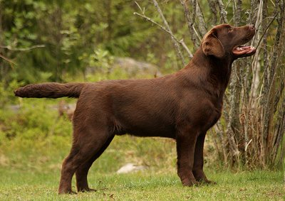 | CH CRUFT'S WINNER NAIKEN WAY OUT WEST (UK)  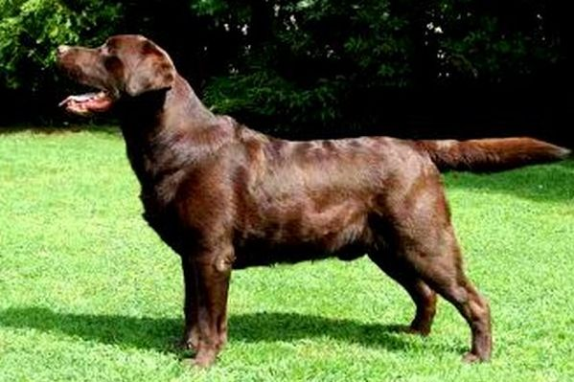 | AM CH Simerdown´s Dr Pepper 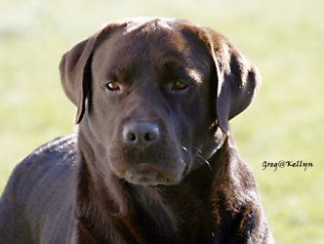
Bukholt Katie at Naiken
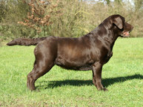
 | MALLORN'S BEYOND CHOCO  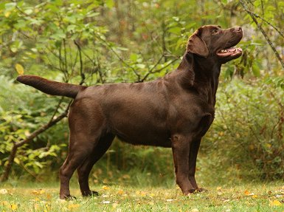 | NORD JW-05  Mallorn´s Capuccino  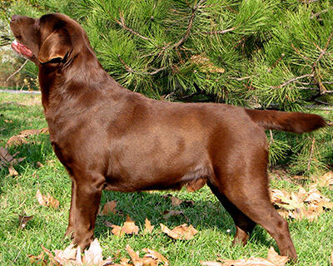
FI CH SU(u)CH
Mallorn´s Chocomotion
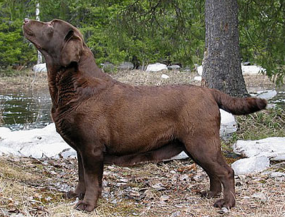
Jinior Club Ch, Junior Rus Ch, Rus Ch, RKF Ch, CACIB, int working test  JIMJAMS SUERTE FROM MAGNIFICOS KINGDOM  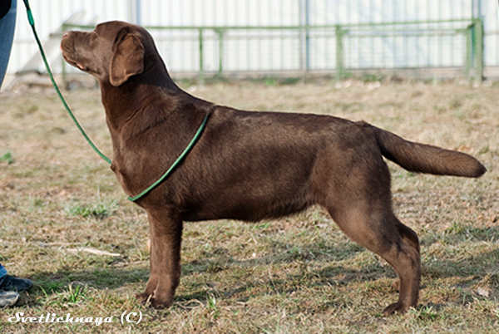 | SHEABOURNE'S FINIGAN RAINBOW (USA)  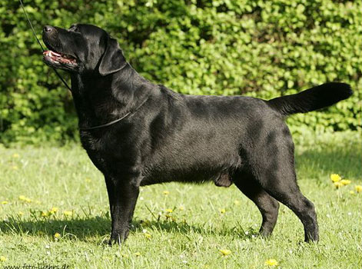 | 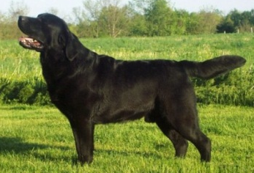 CH Hightide BonaVenture Cap'n Jack
Sheabourne's Chasing Rainbows
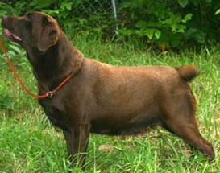
 | CH COCA-COLA FOM MAGNIFICOS KINGDOM 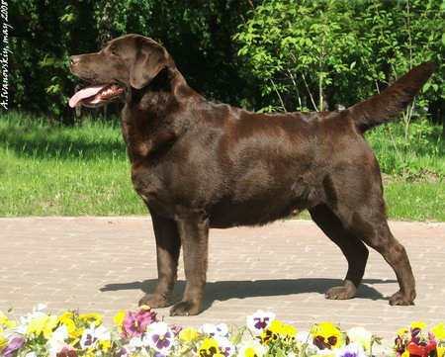 | CH TJOTTE's NOW OR NEVER (SWEDEN)  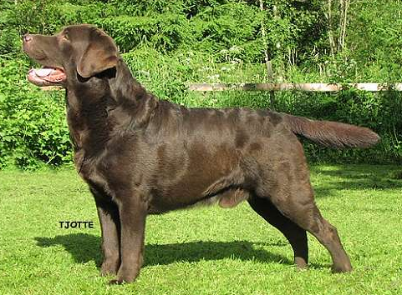
INT CH ENS LUMENS ZHENNY SHINE

